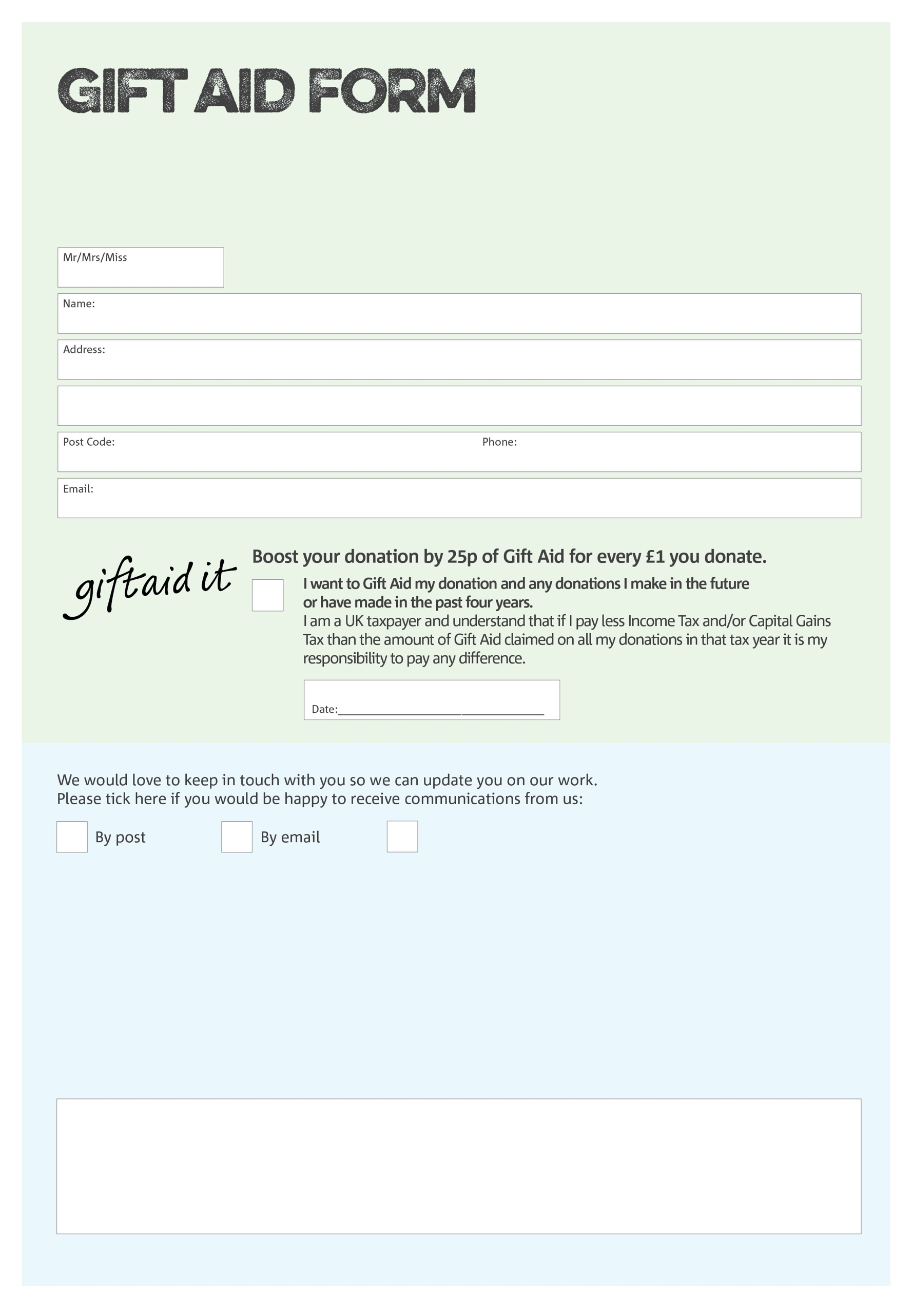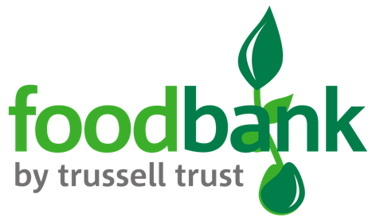

By filling in this form Ballymoney Foodbank will receive an extra 25p for every £1 you give at no extra cost to you. Thank you!

**Data protection**

*'Ballymoney Foodbank is committed to protecting your privacy and will process your personal data in accordance with current Data Protection legislation. Ballymoney Foodbank collects information to keep in touch with you and supply you with information relating to our work. To unsubscribe from our newsletter, send a message to the email address above with the word unsubscribe in the subject line. A full data privacy statement for financial donors is available from the foodbank on request.’*

You can change your preferences any time by contacting us on 075 65840571 or emailing us at

info@ballymoney.foodbank.org.uk

I do not wish to receive future communications from Ballymoney Foodbank

We would love to know why you have chosen to donate to Ballymoney Foodbank. If you would like to share your motivation let us know below:

Charity Number XN 69890. Registered in England & Wales